CIS-11 Course Project Test Documentation
Project B: Test Score Calculator
Team Name: Avengers Assemble
Team Members: David Zaragoza, Javier Martinez, Francisco Colorado
Project Name: Test Score Calculator
Date: June 8, 2026
Advisor: Kasey Nguyen, PhD

Test Case 1 – Assignment Sample Test Case
Input: 52, 87, 96, 79, 61
Expected Output:
Min: 52 Grade: F
Max: 96 Grade: A
Avg: 75 Grade: C
Input Screenshots:

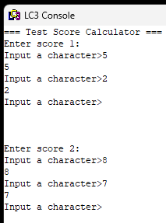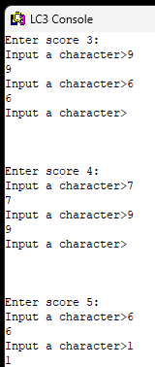
Output Screenshot:
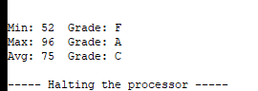

Test Case 2 – Testing Maximum Input Values (100)
Input: 100, 100, 100, 100, 100
Expected Output:
Min: 100 Grade: A
Max: 100 Grade: A
Avg: 100 Grade: A
Input Screenshots:

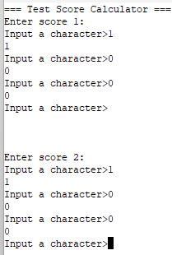

Output Screenshot:
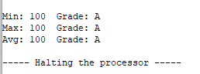

Test Case 3 – Testing Input Validation with Inputs > 100
Input: 150
Expected Output: “Invalid Score. Please enter a value from 0 to 100.”
This program should then prompt the user to re-enter the same score number without advancing the input counter.
Input Screenshot:
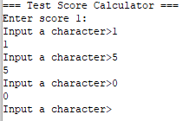

Output Screenshot:
